15.To design DFA trasition diagram in which ab is a substring in automata.

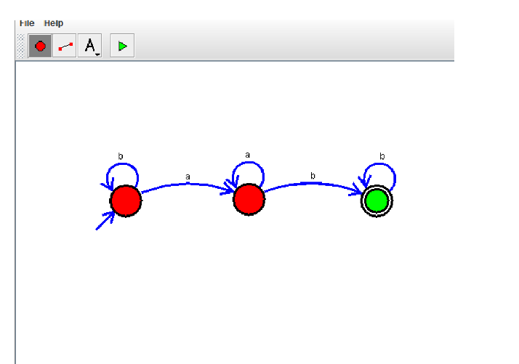

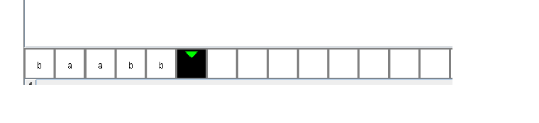

**Result:** Thus designing DFA in which ab exists as substring is done and verified by giving sample inputs.